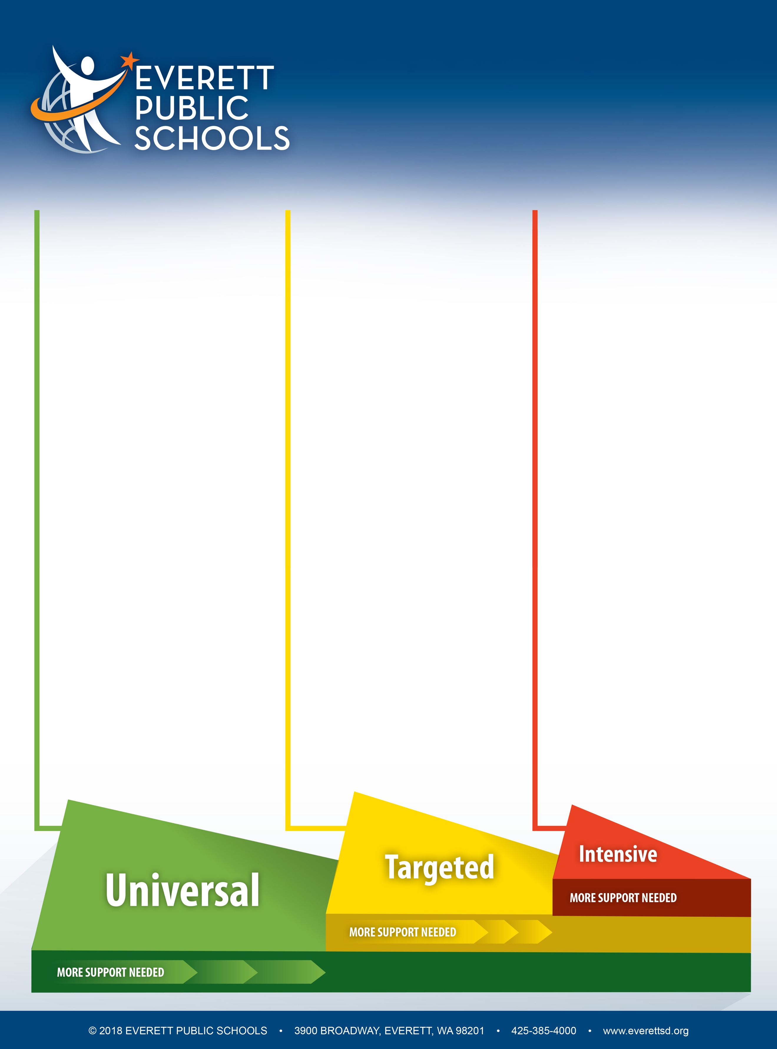

v 1.0 07/18

**Tier 1**

**Behavioral**

* Bullet item here
* Bullet item here
* Bullet item here
* Bullet item here
* Bullet item here

**Academic**

* Bullet item here
* Bullet item here
* Bullet item here
* Bullet item here
* Bullet item here

**Social/Emotional**

* Bullet item here
* Bullet item here
* Bullet item here
* Bullet item here
* Bullet item here

**Tier 2**

**Behavioral**

* Bullet item here
* Bullet item here
* Bullet item here
* Bullet item here
* Bullet item here

**Academic**

* Bullet item here
* Bullet item here
* Bullet item here
* Bullet item here
* Bullet item here

**Social/Emotional**

* Bullet item here
* Bullet item here
* Bullet item here
* Bullet item here
* Bullet item here

**Tier 3**

**Behavioral**

* Bullet item here
* Bullet item here
* Bullet item here
* Bullet item here
* Bullet item here

**Academic**

* Bullet item here
* Bullet item here
* Bullet item here
* Bullet item here
* Bullet item here

**Social/Emotional**

* Bullet item here
* Bullet item here
* Bullet item here
* Bullet item here
* Bullet item here

**Systems of Support**

*A layered continuum of academic, behavioral and   
social/emotional support to meet each learner’s needs*

**School Name Goes Here**